


Scope and Storyboard for Trial

AMR, Manchester

By GQL

Table of Contents

1. Document Revision History 2
1.1. Document Location 2
1.2. Revision History 2
1.3. Approvals 2
1.4. Distribution 2
2. Summary of Scope 3
3. Screen design 3
4. Workflow 5
5. Navigation 6
5.1. Where will the Flow be launched from 6
5.2. Where should the Flow return to 6
6. SQL Tables 6
6.1. Table 6
6.2. Lookup 7
6.3. Field 7
7. Stored Procedures 7
7.1. Fetch 7
7.2. Save 7
8. Document Templates 8

Document Revision History

Document Location
Full File Path
\\Man05sql\Dev\Applications\Flosuite\Scopes\HTMM\Scope and Storyboard Trial\2011-06-29 FL017 Scope and Storyboard_Trial V2.doc

Revision History
Version Number | Revision Date | Summary of Changes | Changes marked | Author
0.1 | 09/02/2010 | First issue | N/A | GQL
0.2 | 29/06/2011 | Update for Requirements Gathering | N/A | GQL
0.3 | 25/07/2011 | Update from Requirements Gathering | No to many | GQL

Approvals
Name | Signature | Title | Date of Issue | Version

Distribution
Name | Title | Date of Issue | Version

Summary of Scope

The purpose of this scope is to outline the provisions that the FloCase system will need to handle the process of preparing for a Trial and dealing with its outcome.

The main hub of this will be a pre-trial checklist task that will be scheduled for the Fee Earner but with the intention of being completed as a pre-trial review with the supervisor of the matter.

Screen design

  - Pre-Trial Preparation

Form Availability

The pre-trial checklist will be scheduled automatically for the Lawyer upon the insertion of a trial date or trial window key dates(s) upon the FloCase system via the Directions tab. It will be scheduled for 8 weeks before either the trial date entered or beginning of the trail window with a view of the Lawyer completing the activity as part of a pre-trial review with the Supervisor on the matter. The activity should escalate to the supervisor 1 week before the trial date entered.

Form Behaviour On Load

The form should load with the selected Court and either the Trail Date or Trial Window from the directions tab pre populated via a new stored procedure LTMM_PreTrialPrep_Fetch.

Form Items

The pre-trial checklist screen will be split into five tabbed sections, Directions Summary, Lay Witness Summary, Expert Witness Summary, Counsel Summary and Quantum and Liability Review and will look like the following diagrams with controls.

In addition to these 5 tabbed sections the following controls will be visible at the top of the form regardless of the tab selected:
Court – Label as stated with associated read only textbox displaying the court linked to the trial date/window key date(s) that spawned the Pre-Trial Preparation task.
Trial Date – Label as stated with associated date picker which will either display the start date of a trial window or the Trail date itself.
Trial Window? – Label as stated with associated checkbox that when checked displays an associated date picker that either displays the end date of the associated trail window key date or allows the user to enter a trial window end key date.
Reschedule? – Label as stated with associated checkbox that when checked displays an associated date picker that allows the user to enter a date that the task will be rescheduled on upon submission.

Trial Date and window functionality

The trail date/window key dates displayed on this screen should be intrinsically linked to the corresponding direction key dates attached to the Court displayed in the Court text box. If the user amends these dates from this screen the key dates on the direction tab should also be amended. Either a Trial date or a Trial Window must be entered upon submission of this form. Due to the nature of these key dates this form should not be available adhoc as it should be linked to the court that triggered its scheduling.

Form items for the tabs are listed in the subsequent sub sections 3.1.1 – 3.1.5 inclusive below.

Form Behaviour on Submit

Should return to the Matter Landing Page.

If Reschedule <> ‘’ – Schedule Pre-Trial Preparation for the Fee Earner on the Matter for the date entered in Reschedule

If Reschedule = ‘’ Write history line Pre-Trial Preparation Complete

If Reschedule = ‘’ schedule Record Trial Result for the Lawyer on the matter for either the Trail date or the Trial Window start date.

Use New Stored Procedure LTMM_PreTrialPrep_Save to save the following details entered on the form:
- Trial Date or Trial Window
- Plus other items listed in the subsequent sub sections 3.1.1 – 3.1.5 inclusive below.

Form Behaviour on Cancel

Return to the matter landing page.

    - Pre-Trial Preparation – Directions Summary Tab

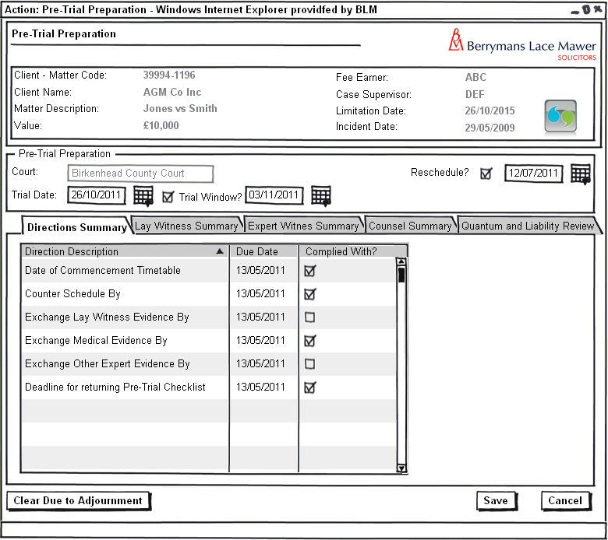
Figure 1 – Pre-Trial Preparation – Directions Tab

The directions summary above will allow the user to review all the court directions pre-trial and check them off as completed.

Form Items

Directions Summary - Grid listing all active directions attached to the court linked to the trial date/window key date(s) that spawned the Pre-Trial Preparation task. The user should be able to check of each direction in the list as complied with. Grid should be populated via a new stored procedure LTMM_PreTrialPrepDirections_Fetch which should mark any directions that have been complied with previously on this form.
Clear Due to Adjournment – Label as stated with associated button that has many uses on this screen but specifically on this tab it should clear all the complied with checkboxes in the event of the user clicking on the button.

Form Behaviour on Submit

Use New Stored Procedure LTMM_PreTrialPrep_Save to save the following details entered on the form:
- Each direction and if it has been complied with or not

    - Pre-Trial Preparation – Lay Witness Summary Tab

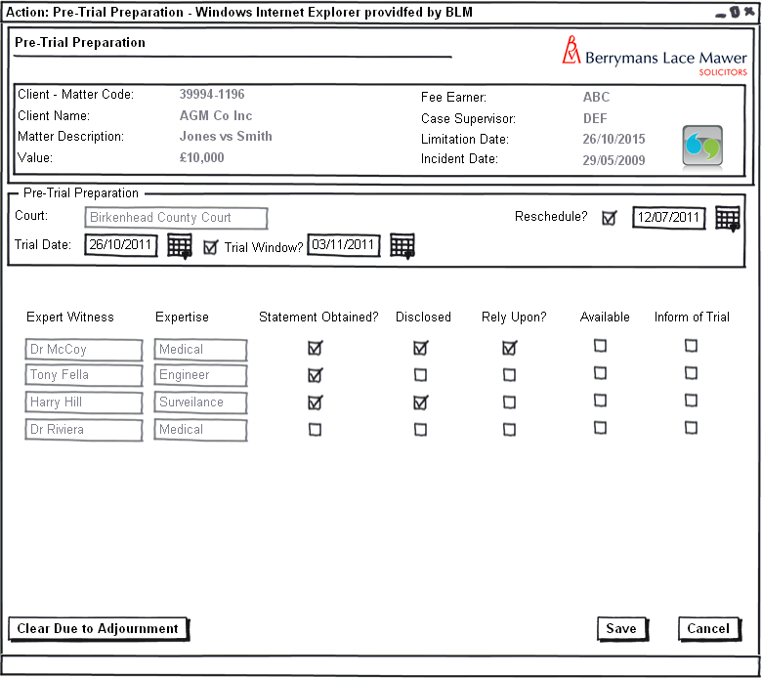 Figure 2 – Pre-Trial Preparation – Lay Witness Tab

The lay witness section detailed above will allow the user to visually check off those lay witnesses that have provided a statement, whether they can be relied upon and subsequently if they should be informed of trial. Tab should be invisible if there are no lay witnesses associated with the matter.

Form Behaviour On Load

The form should load with each lay witness listed with the following details:
- Statement Obtained.
- Disclosed?
- Rely Upon?
- Available.
- Inform of Trial
pre populated via a new stored procedure LTMM_PreTrialPrepContact_Fetch.

Form Items

The following form items should be repeated on the form for each lay witness associated with the matter.
Lay Witness – Label as stated with associated read only textbox displaying the name of the lay witness.
Statement Obtained – Label as stated with associated checkbox.
Disclosed? – Label as stated with associated checkbox.
Rely Upon? – Label as stated with associated checkbox.
Available – Label as stated with associated checkbox.
Inform of Trial – Label as stated with associated checkbox.
Clear Due to Adjournment – Label as stated with associated button that has many uses on this screen but specifically on this tab it should clear all the checkboxes associated with each lay witness in the event of the user clicking on the button.

Form Behaviour on Submit

Use New Stored Procedure LTMM_PreTrialPrep_Save to save the following details entered on the form:
- The following information for each lay witness:
  - Statement Obtained.
  - Disclosed?
  - Rely Upon?
  - Available.
  - Inform of Trial

    - Pre-Trial Preparation – Expert Witness Summary Tab

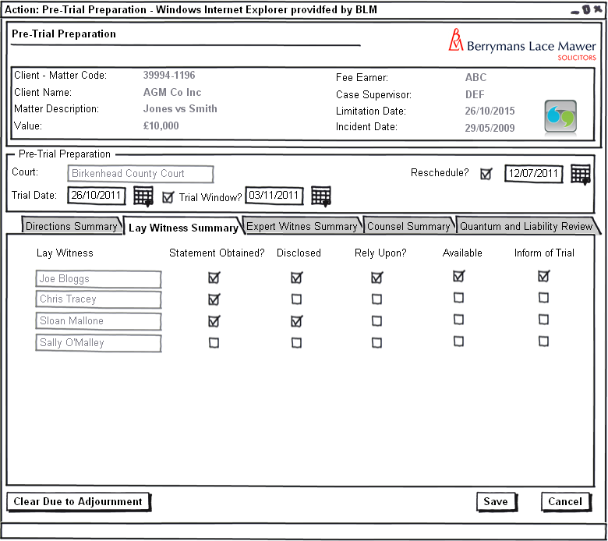
Figure 3 – Pre-Trial Preparation – Expert Witness Tab

The expert witness section will allow the user to review any expert witnesses that are attached to the matter, these witnesses can then be assessed in terms of their field of expertise if any evidence provided has been disclosed if they are required to give oral evidence and then subsequently if they are to be informed of the trial.

Form Behaviour On Load

The form should load with each Expert witness listed with the following details:
- Statement Obtained.
- Disclosed?
- Rely Upon?
- Available.
- Inform of Trial
pre populated via a new stored procedure LTMM_PreTrialContact_Fetch.

Form Items

The following form items should be repeated on the form for each expert witness associated with the matter.

Expert Witness – Label as stated with associated read only textbox displaying the name of the Expert witness.
Expertise – Label as stated with associated read only textbox displaying the field of the Expert witness.
Statement Obtained – Label as stated with associated checkbox.
Disclosed? – Label as stated with associated checkbox.
Rely Upon? – Label as stated with associated checkbox.
Available – Label as stated with associated checkbox.
Inform of Trial – Label as stated with associated checkbox.
Clear Due to Adjournment – Label as stated with associated button that has many uses on this screen but specifically on this tab it should clear all the checkboxes associated with each expert witness in the event of the user clicking on the button.

Form Behaviour on Submit

Use New Stored Procedure LTMM_PreTrialPrep_Save to save the following details entered on the form:
- The following information for each expert witness:
  - Statement Obtained.
  - Disclosed?
  - Rely Upon?
  - Available.
  - Inform of Trial

    - Pre-Trial Preparation – Counsel Summary Tab

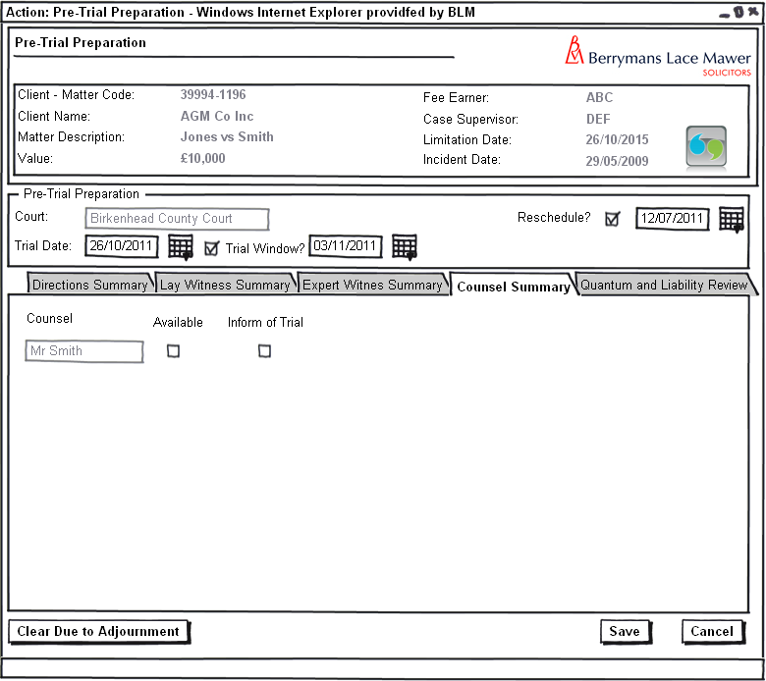
Figure 4 – Pre-Trial Preparation – Counsel Summary Tab

The counsel section will allow the user to review any counsel that are attached to the matter and if they are available and informed of the trial.

Form Behaviour On Load

The form should load with each counsel listed with the following details:
- Available.
- Inform of Trial
pre populated via a new stored procedure LTMM_PreTrialPrepContact_Fetch.

Form Items

The following form items should be repeated on the form for each Counsel associated with the matter.

Counsel – Label as stated with associated read only textbox displaying the name of the Expert witness.
Available – Label as stated with associated checkbox.
Inform of Trial – Label as stated with associated checkbox.
Clear Due to Adjournment – Label as stated with associated button that has many uses on this screen but specifically on this tab it should clear all the checkboxes associated with each counsel in the event of the user clicking on the button.

Form Behaviour on Submit

Use New Stored Procedure LTMM_PreTrialPrep_Save to save the following details entered on the form:
- The following information for each counsel:
  - Available.
  - Inform of Trial

    - Pre-Trial Preparation – Quantum and Liability Review Tab

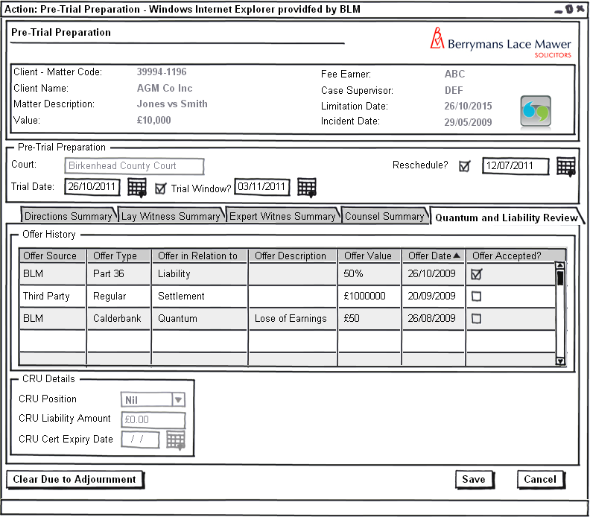Figure 5 – Pre-Trial Preparation – Quantum and Liability Review Tab

The Quantum and Liability review section will allow the user to review all the offers attached to the system and the CRU details

Form Items

Offer History - Grid listing all offers attached to the matter. Grid should be populated via the existing stored procedure LTMM_Offers_Fetch.
CRU Position – Label as stated with associated read only textbox showing the current CRU position on the matter (via the stored procedure LTMM_ClaimantCRU_Fetch).
CRU Liability Amount – Label as stated with associated read only textbox showing the current CRU liability amount on the matter (via the stored procedure LTMM_ClaimantCRU_Fetch).
CRU Cert Expiry Date – Label as stated with associated read only textbox showing the current CRU Cert Expiry Date on the matter (via the stored procedure LTMM_ClaimantCRU_Fetch).
Clear Due to Adjournment – Label as stated with associated button that has no functionality relating to this tab.

CRU Note – Obviously the CRU is technically attached to each claimant on the matter but there should only be 1 claimant per matter this scope assumes this to be true and should just default to the first claimant on the matters CRU details.

  - Record Trial Result

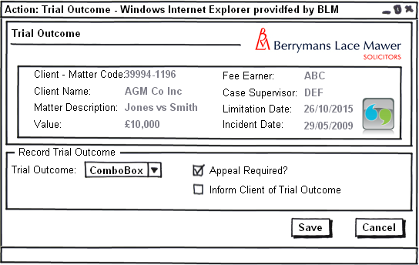
Figure 6 – Trial Outcome result

Form Availability

This form will be scheduled only from the Pre Trial Preparation task detailed in section 3.1. This form should not be available adhoc from the case actions screen.

Form Behaviour On Load

The form should load with no data pre-populated.

Form Items

Trial Outcome – Label as stated with associated Mandatory Combo box having the following options (Populated using LTMM_LookupCodes_Fetch with @LookupTypeCode = 'TRLOTCM’, @BlankRow = 1):
- BLM
- Third Party

Appeal Required? – Label as stated with associated checkbox denoting if an appeal is required or not (Checked = Required).

Inform Client of Trial Outcome – Label as stated with associated checkbox denoting if we need to inform client of trial result or not (Checked = Inform).

Form Behaviour on Submit

Should return to the matter landing page.

If Appeal Required? <> ‘’ set all active directions attached to the matter as inactive.
If Inform Client of Trial Outcome <> ‘’ produce adhoc letter to the client for the user to edit.

Form Behaviour on Cancel

Should return to the matter landing page.

Workflow

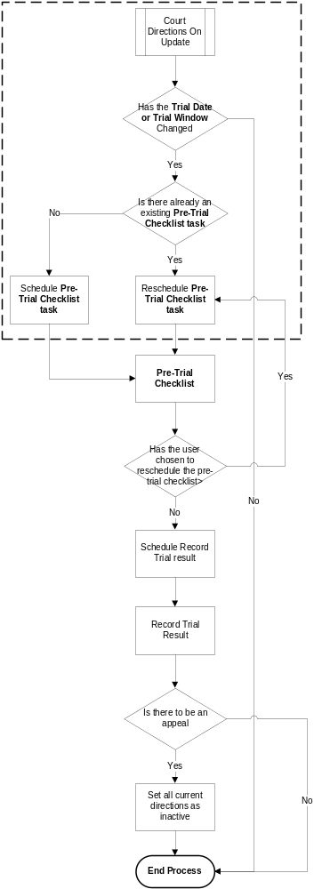

Navigation

Where will the Flow be launched from

The Flow will originate from the Court Directions and is instigated when a Change is made to the Trial date.

Where should the Flow return to

The Flow should return to the matter landing page.

SQL Tables

Table

A new table TrialWitnessSummary required which will fit into the existing database structure as follows:

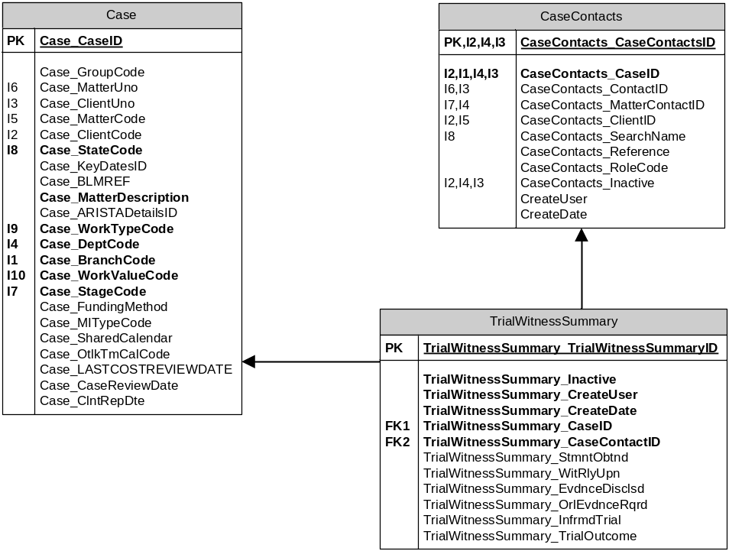

New Table and Fields required as follows:
- TrialWitnessSummary Table
  - TrialWitnessSummary_TrialWitnessSummaryID – Type int
  - TrialWitnessSummary_Inactive – Type bit
  - TrialWitnessSummary_CreateUser – Type nvarchar(255)
  - TrialWitnessSummary_CreateDate – Type smalldatetime
  - TrialWitnessSummary_CaseID – Type int
  - TrialWitnessSummary_CaseContactID – Type int
  - TrialWitnessSummary_StmntObtnd – Type bit
  - TrialWitnessSummary_WitRlyUpn – Type bit
  - TrialWitnessSummary_EvdnceDisclsd – Type bit
  - TrialWitnessSummary_OrlEvdnceRqrd – Type bit
  - TrialWitnessSummary_InfrmdTrial – Type bit
  - TrialWitnessSummary_TrialOutcome – Type nvarchar(10)

Lookup

The Following fields should correspond to drop downs with options as stated:
- ClientRules_AckInstReq
  - BLM
  - Third Party

Field

n/a

Stored Procedures

Fetch

New stored procedure LTTM_TrialWitnessSummary_Fetch required fetching all the witness trial details of a given matter:
Inputs:
  - CaseID– int – mandatory use the caseid associated with this matter.
  - Username – nvarchar(255) – mandatory use system.username within Flosuite
Outputs
  - TrialWitnessSummary_TrialWitnessSummaryID – For reference only
  - TrialWitnessSummary_CaseID – For reference only
  - TrialWitnessSummary_CaseContactID – For reference only
  - CaseContacts_SearchName – Map to the Witness Name in the Witness Summary Grids on the Pre Trial Checklist
  - CaseContacts_RoleCode – Map to the Witness Field of Expertise in the Witness Summary Grids on the Pre Trial Checklist
  - TrialWitnessSummary_StmntObtnd – Map to Statement Obtained in the Witness Summary Grids on the Pre Trial Checklist
  - TrialWitnessSummary_WitRlyUpn – Map to Rely Upon in the Witness Summary Grids on the Pre Trial Checklist
  - TrialWitnessSummary_EvdnceDisclsd – Map to Evidence Disclosed in the Witness Summary Grids on the Pre Trial Checklist
  - TrialWitnessSummary_OrlEvdnceRqrd – Map to Oral Evidence Required in the Witness Summary Grids on the Pre Trial Checklist
  - TrialWitnessSummary_InfrmdTrial – Map to Informed of Trial in the Witness Summary Grids on the Pre Trial Checklist

Save

New stored procedure LTTM_TrialWitnessSummary_Save required attaching a witness trial details to a given matter:
Inputs:
  - Case_Caseid – nvarchar(10) – mandatory use the Case_Caseid attached to the matter at inception.
  - TrialWitnessSummary_CaseContactID – Of the contact the Trial summary relates to
  - TrialWitnessSummary_StmntObtnd – Map to Statement Obtained in the Witness Summary Grids on the Pre Trial Checklist
  - TrialWitnessSummary_WitRlyUpn – Map to Rely Upon in the Witness Summary Grids on the Pre Trial Checklist
  - TrialWitnessSummary_EvdnceDisclsd – Map to Evidence Disclosed in the Witness Summary Grids on the Pre Trial Checklist
  - TrialWitnessSummary_OrlEvdnceRqrd – Map to Oral Evidence Required in the Witness Summary Grids on the Pre Trial Checklist
  - TrialWitnessSummary_InfrmdTrial – Map to Informed of Trial in the Witness Summary Grids on the Pre Trial Checklist
Outputs
  - TrialWitnessSummary_TrialWitnessSummaryID

Document Templates

n/a

/tmp/lo/0000.doc

